|  |
| --- |
|  |
| User Guide |
| Daniel Elstob |
|  |
|  |
|  |

|  |
| --- |
|  |

Contents

Homepage 2

Forms 3

Aircraft Form 3

Airport Form 3

Bookings Form 4

Customers Form 5

Flights Form 6

Payments Details Form 7

Reports 8

Revenue Per Route Report 8

Invoice Report 9

Flight Seats Report 9

Form Buttons 10

First Record 10

Previous Record 11

Next Record 12

Last Record 13

New Record 14

Delete Record 15

Close Record 16

Report Buttons 17

User Input 17

Print Report 19

Close Report 20

# Homepage

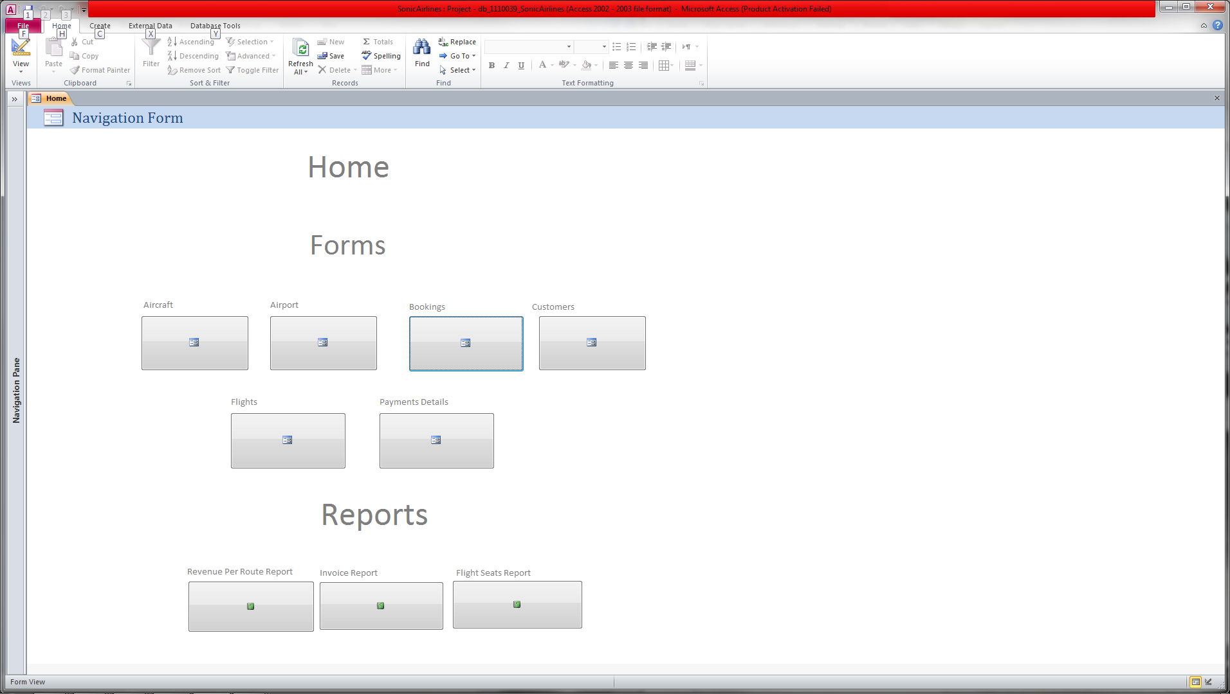

The homepage form as shown above is where you will be able to navigate around all the different forms to view the information in the tables or to add more records. You can also view the reports that will query the information you want.

## Forms

### Aircraft Form

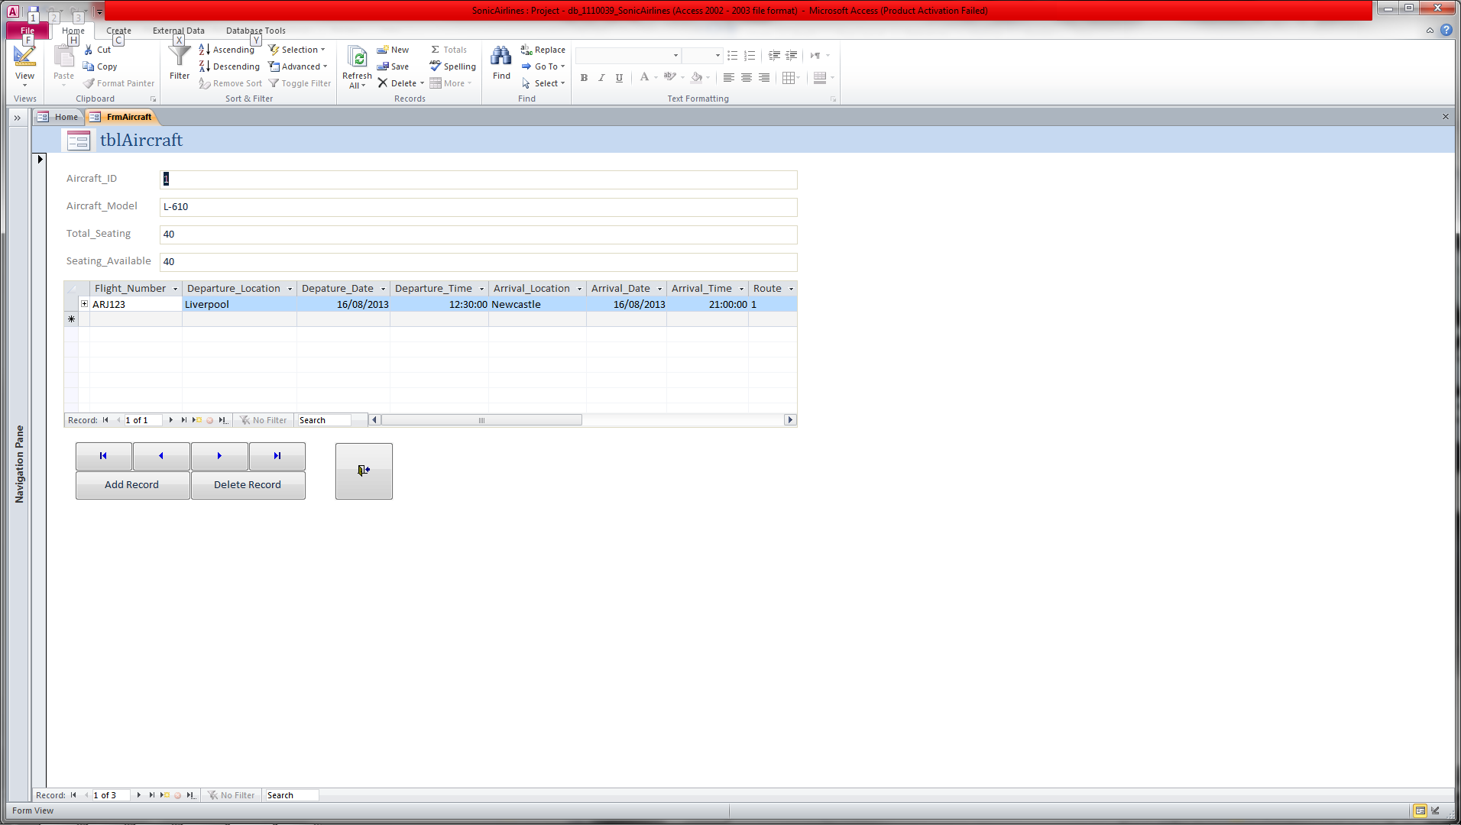

Above is the Aircraft Form that will show the aircraft information and a subform of the flight details that belong to that particular aircraft.

### Airport Form

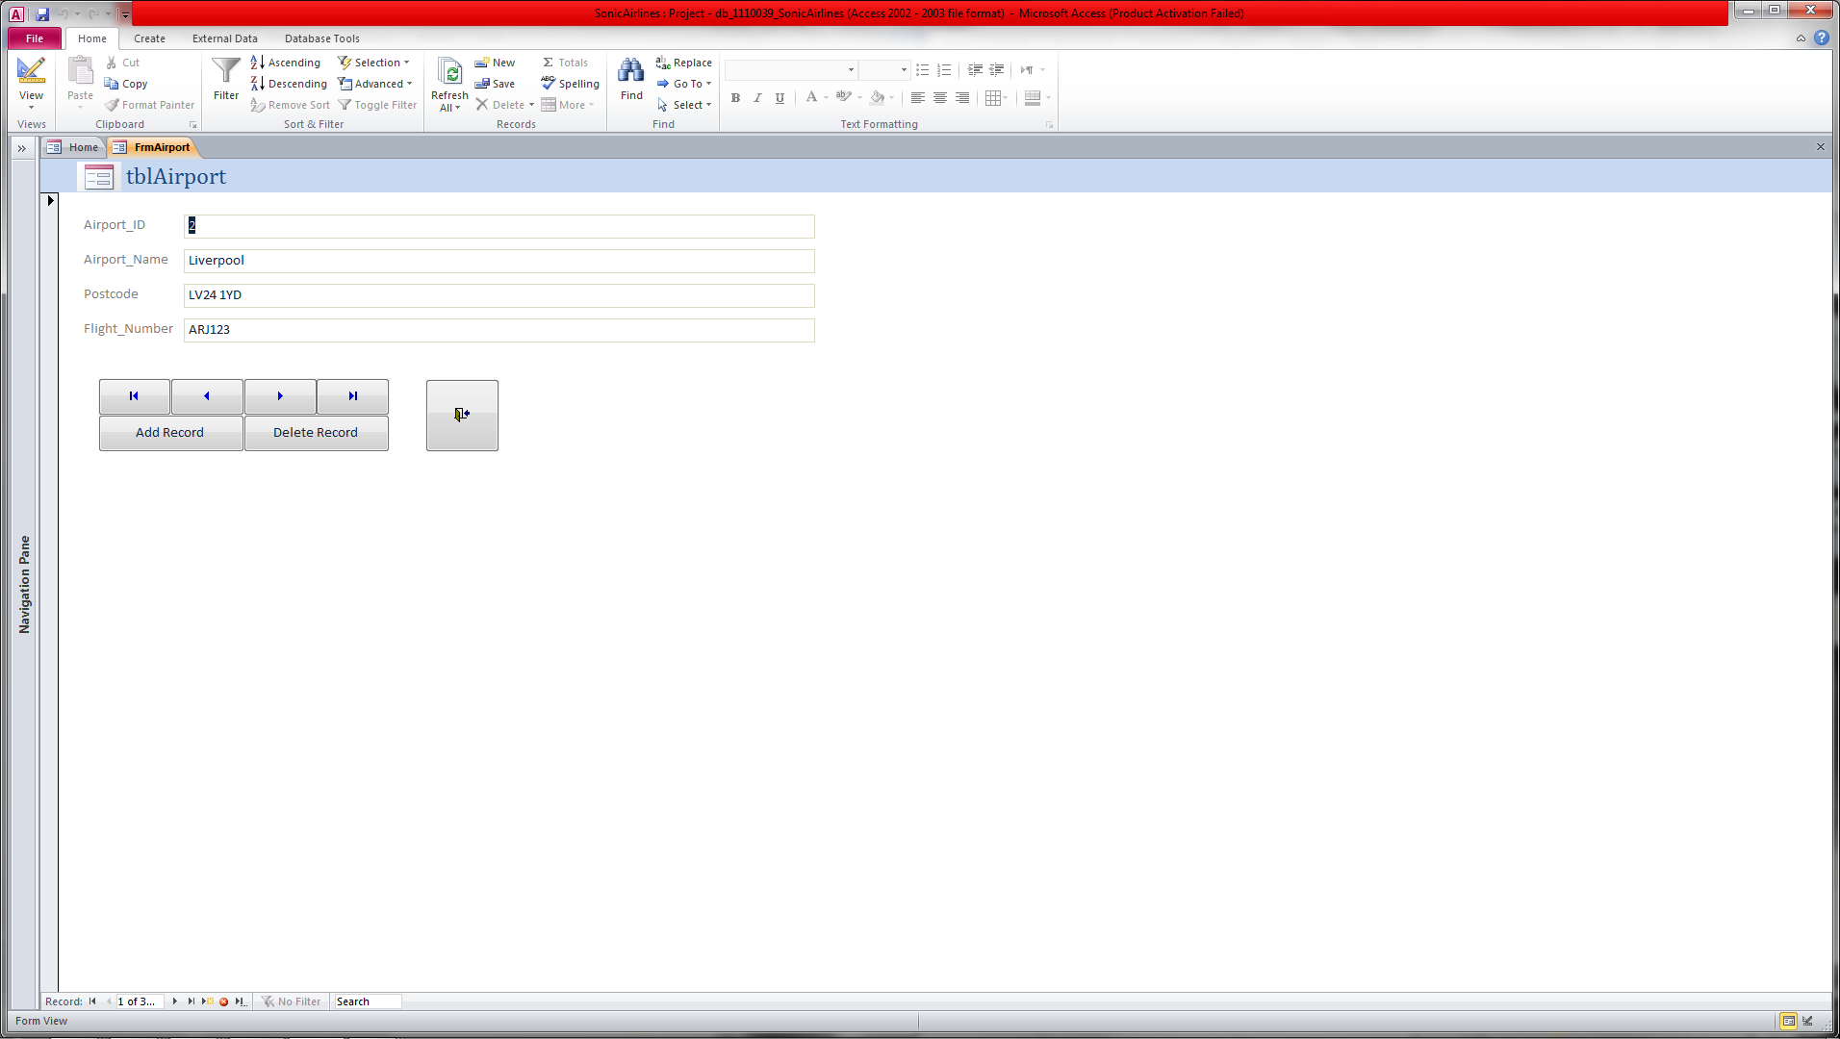

Above is the Airport Form that show the information of the airports that the flights will be going to or from.

### Bookings Form

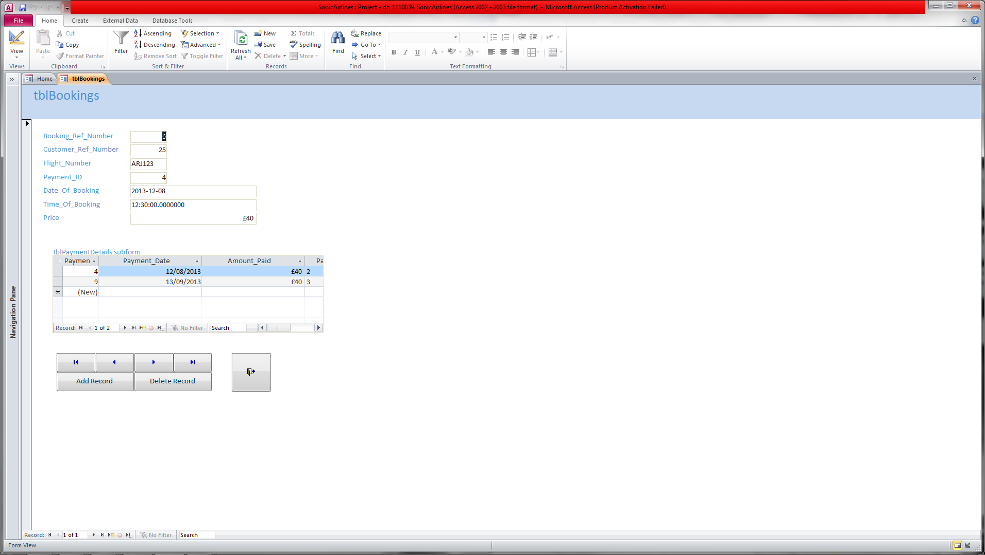

Above is the Booking Form that shows the booking information from the customers and a subform with payment details to show if payment for the booking is overdue or not.

### Customers Form

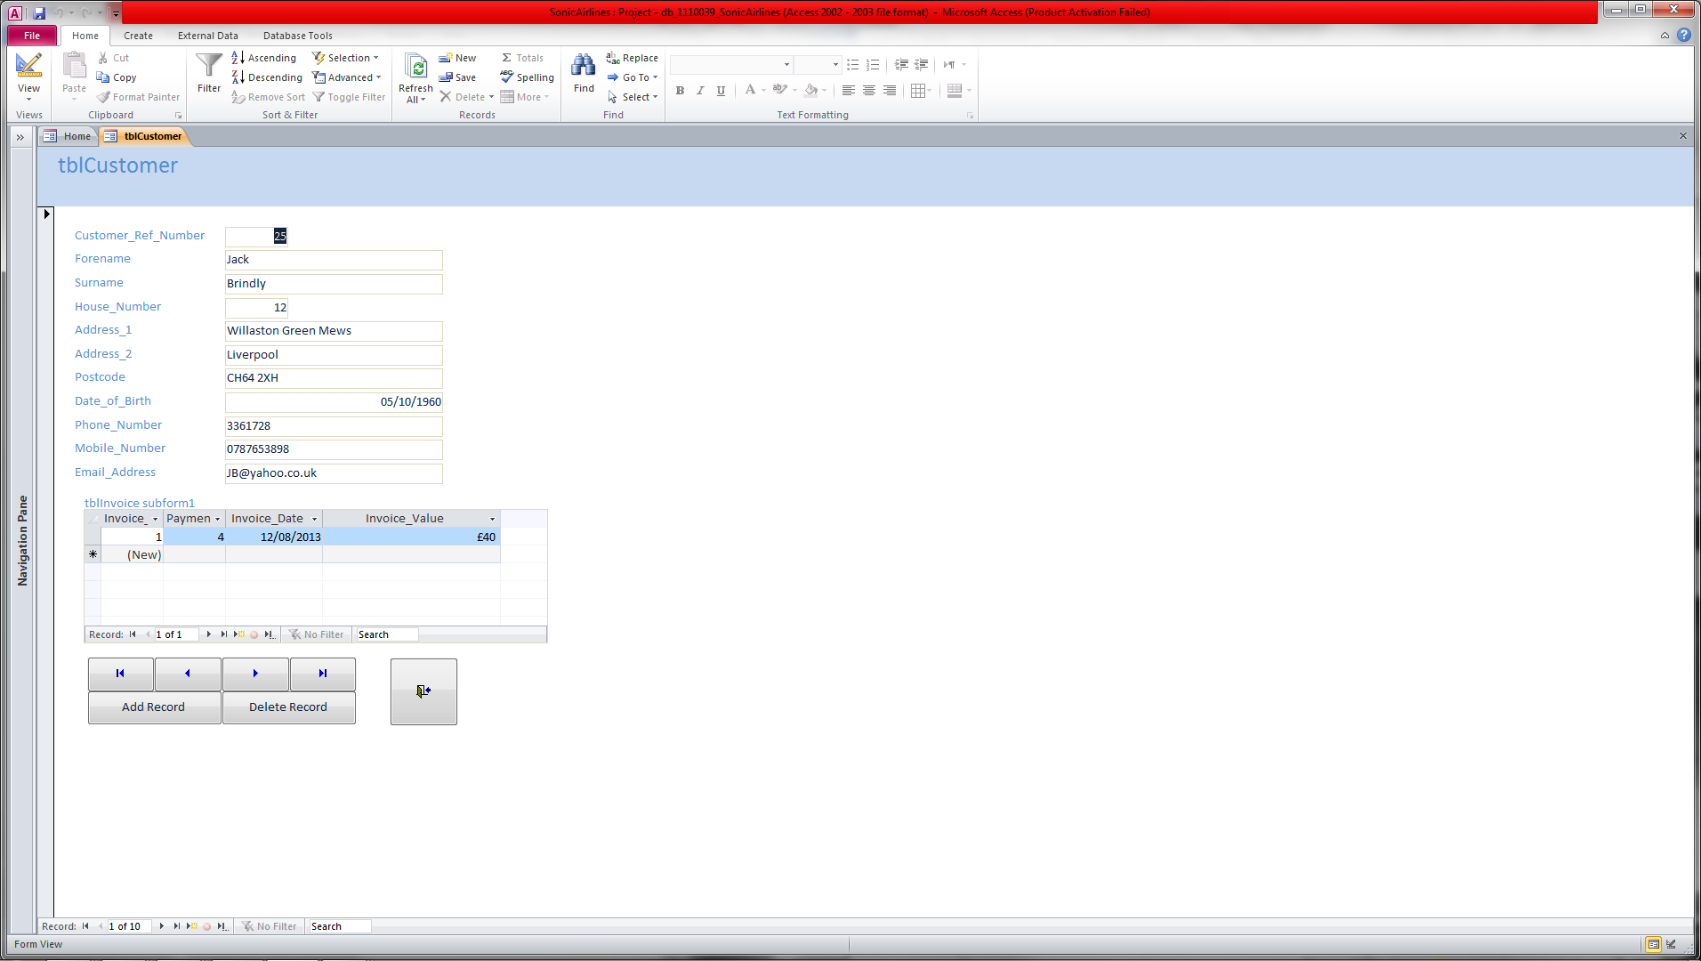

Above is the Customer Form that will show the customer information and a subform of the invoice details that belong to that particular customer.

### Flights Form

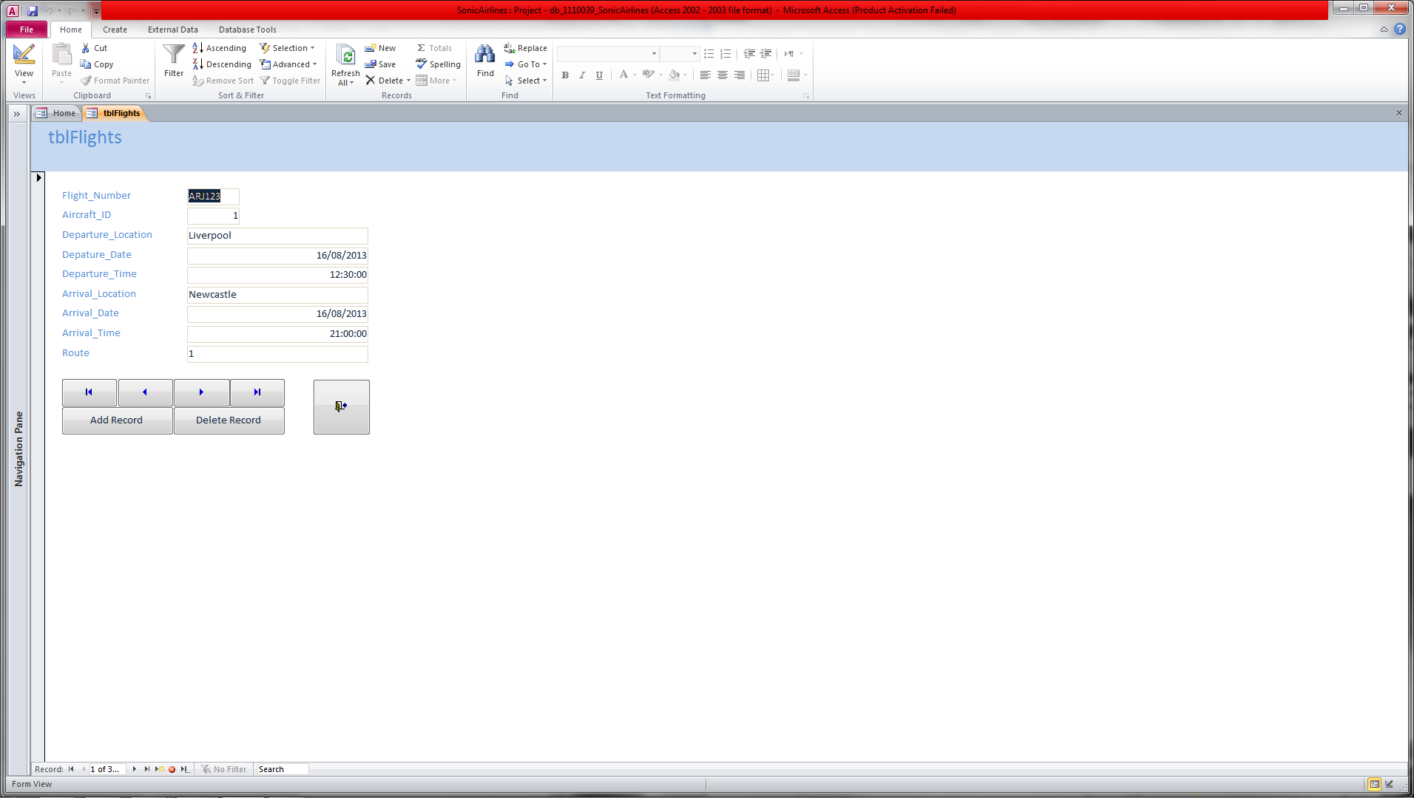

Above is the Flights Form that will show the flight .

### Payments Details Form

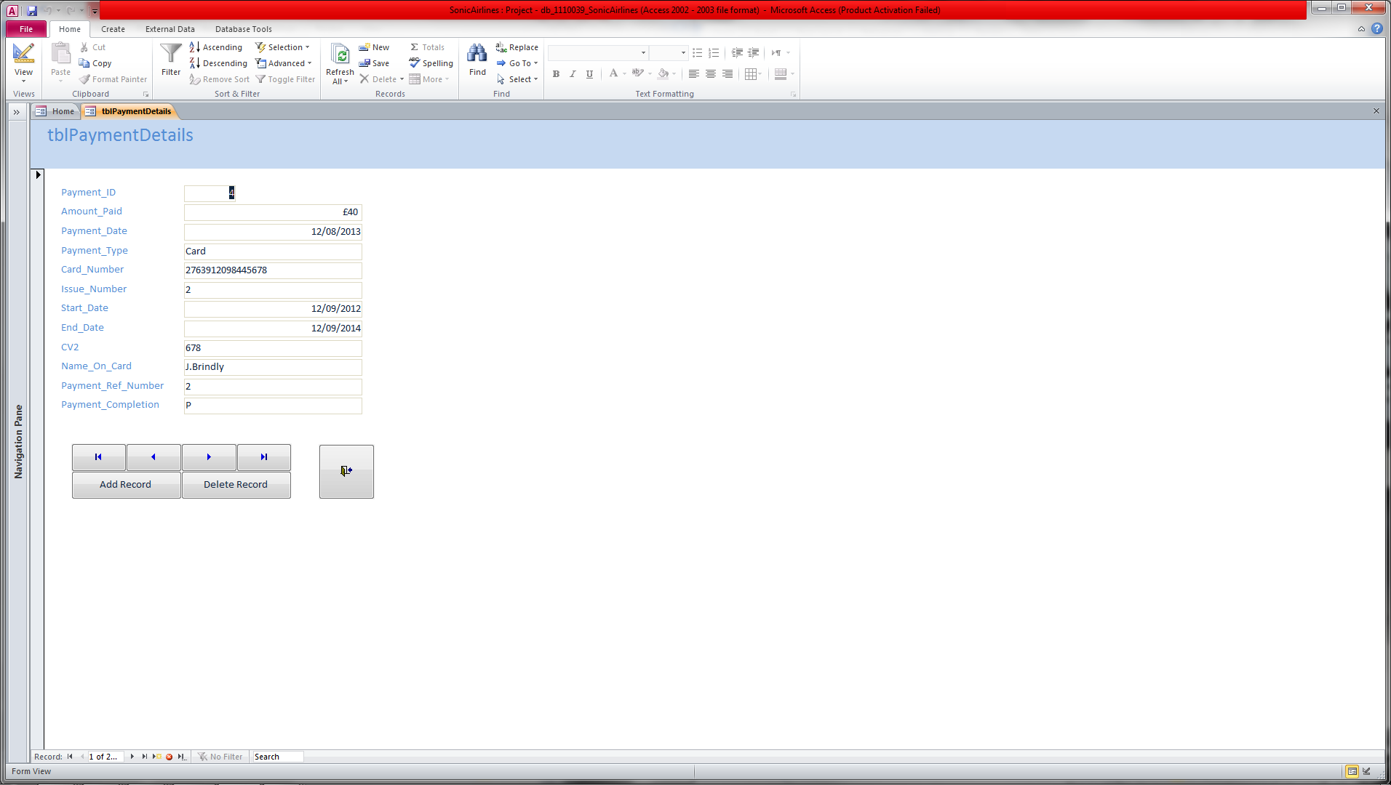

Above is the Payment Details Form that will show the payment information.

## Reports

### Revenue Per Route Report

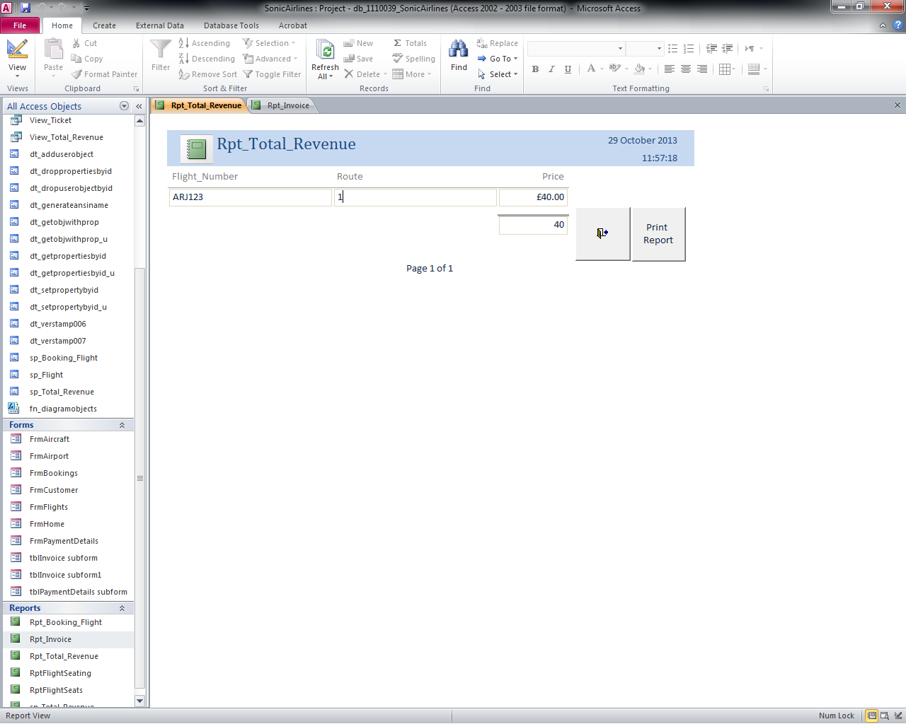

Above is the Total revenue report that uses the flight number and route from user input and then the price from the table with the overall total in the cell underneath the price.

### Invoice Report

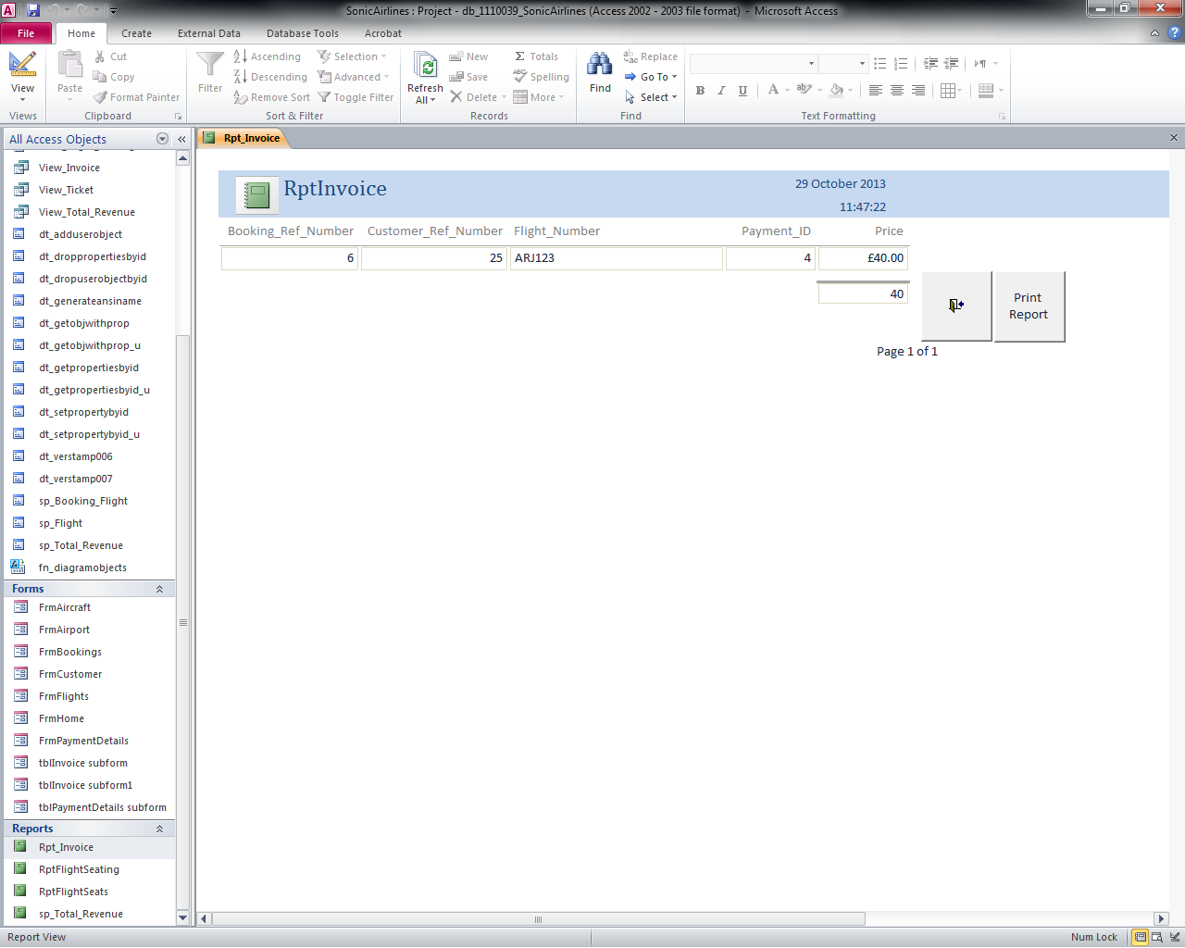

Above is the Invoice that has been filled with booking details ready to be sent to the customer.

### Flight Seats Report

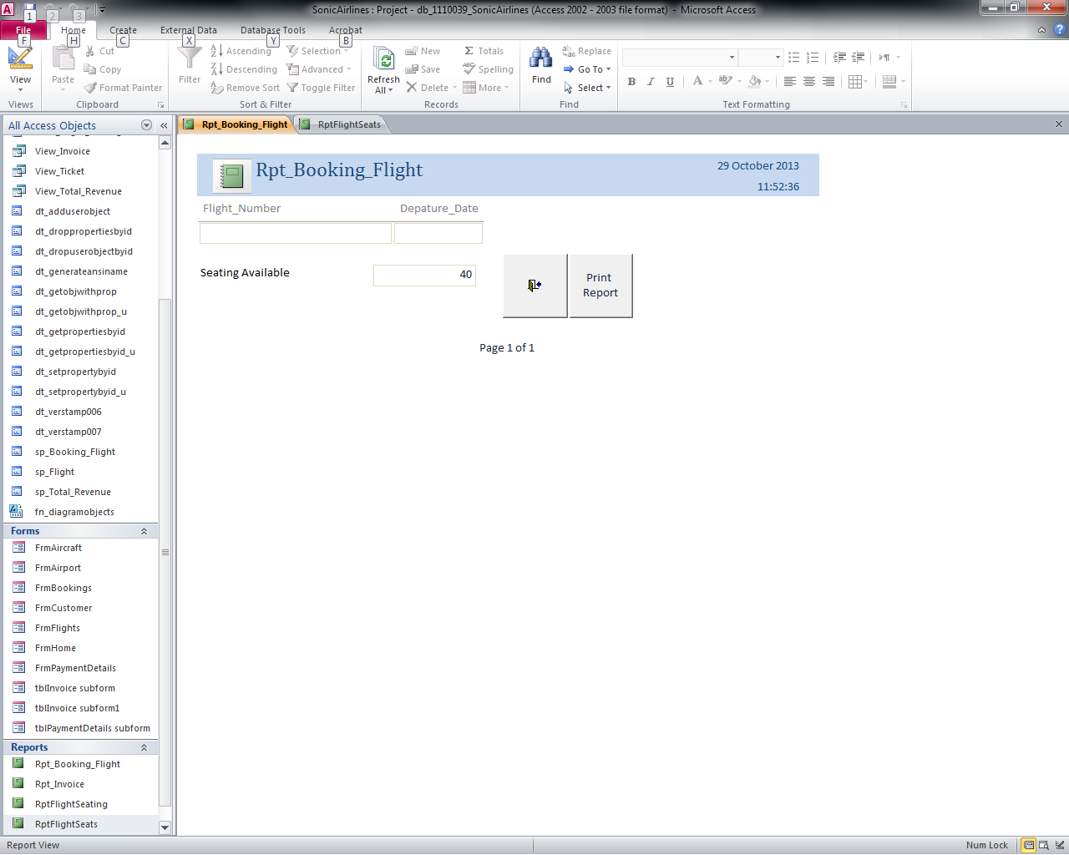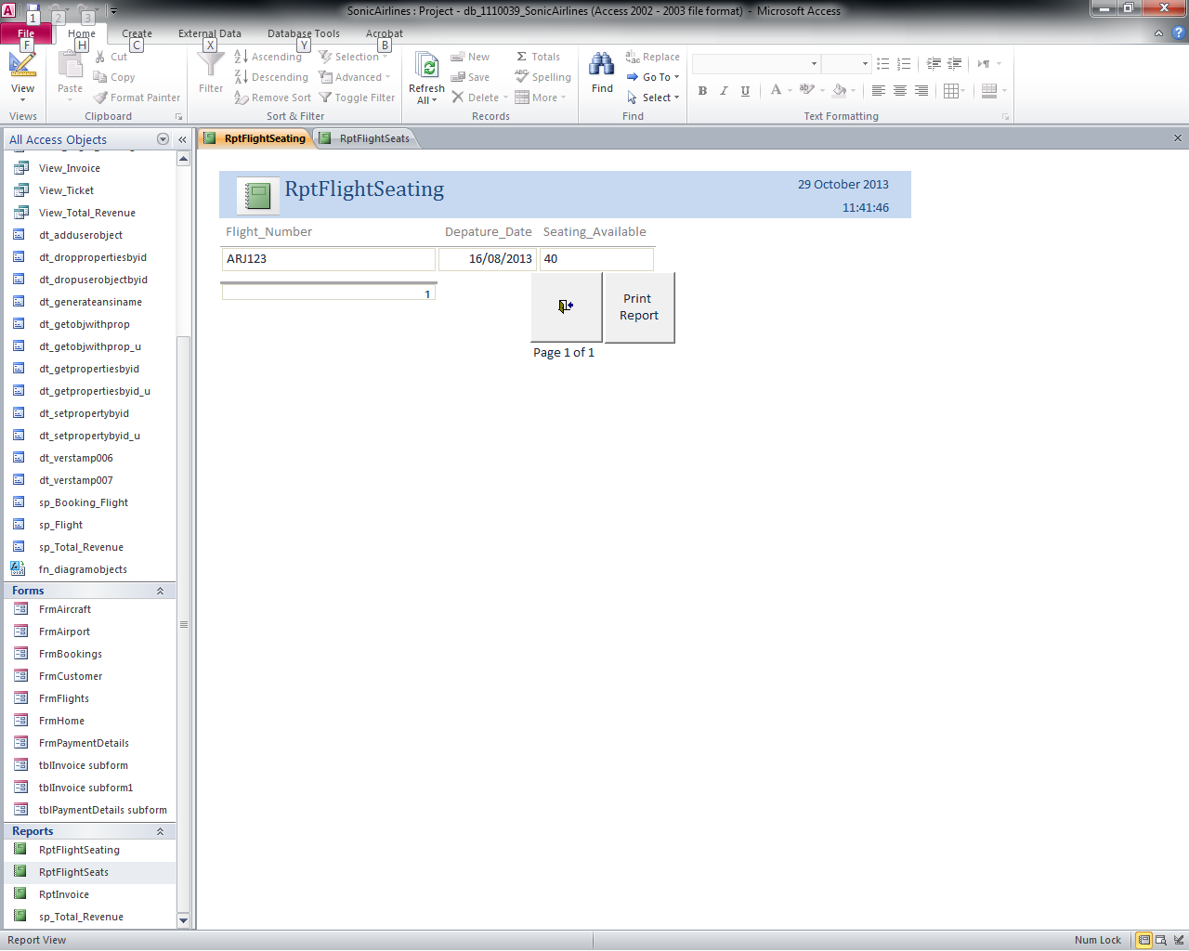

Above is the Flight Seats report with the result of the user’s input data queried.

## Form Buttons

### First Record

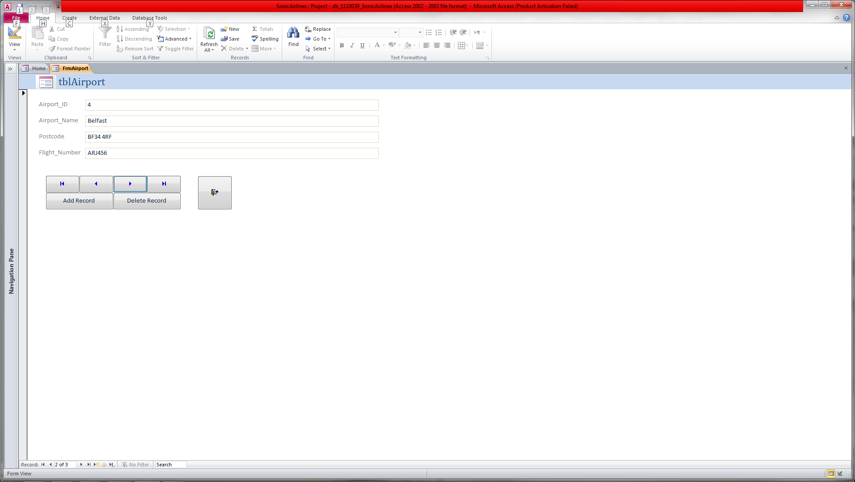

To go to the first record in the table simply click the button shown above. This will take the user from the record they are on to the first record. As shown above the user is currently on record 4 and after clicking the first record button the user is taken to the first record in the table which happens to be record 2 as shown below.



### Previous Record



To go to the previous record in the table simply click the button shown above. This will take the user from the record they are on to the previous record. As shown above the user is currently on record 4 and after clicking the previous record button the user is taken to the previous record in the table which happens to be record 2 as shown below.



### Next Record



To go to the next record in the table simply click the button shown above. This will take the user from the record they are on to the next record. As shown above the user is currently on record 2 and after clicking the first record button the user is taken to record 4 in the table.



### Last Record



To go to the last record in the table simply click the button shown above. This will take the user from the record they are on to the last record. As shown above the user is currently on record 2 and after clicking the last record button the user is taken to the last.

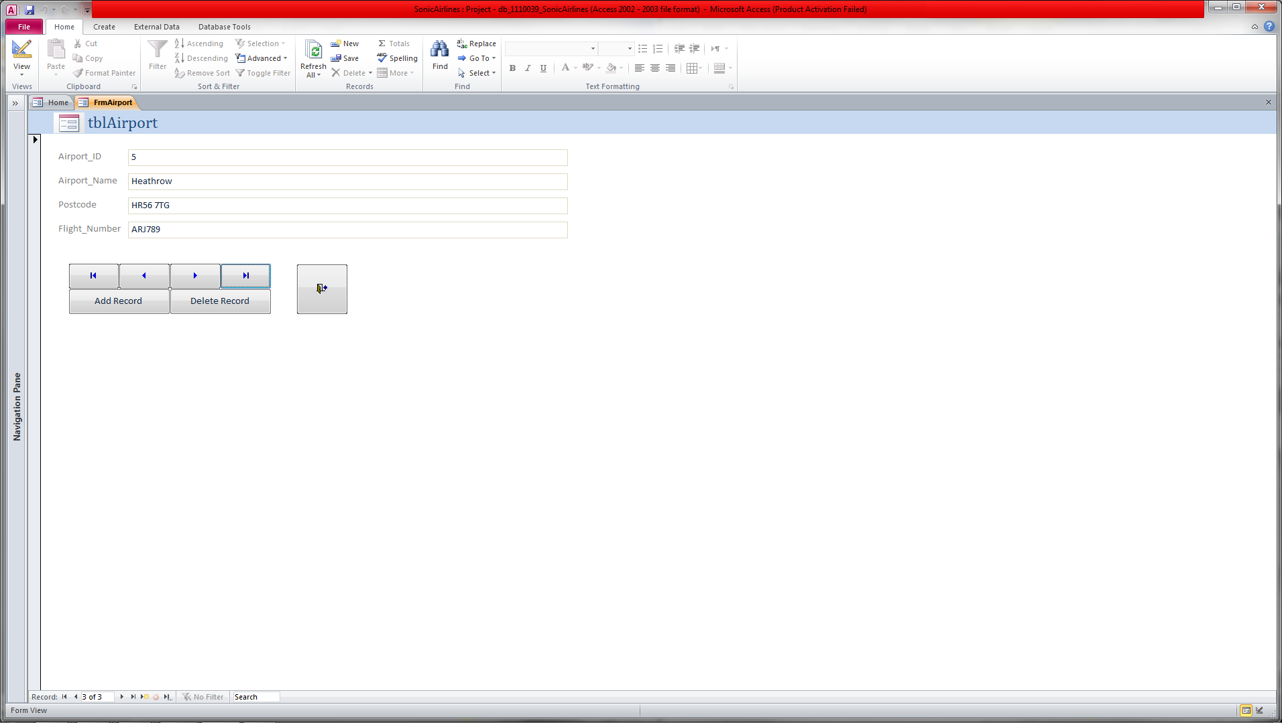

### New Record

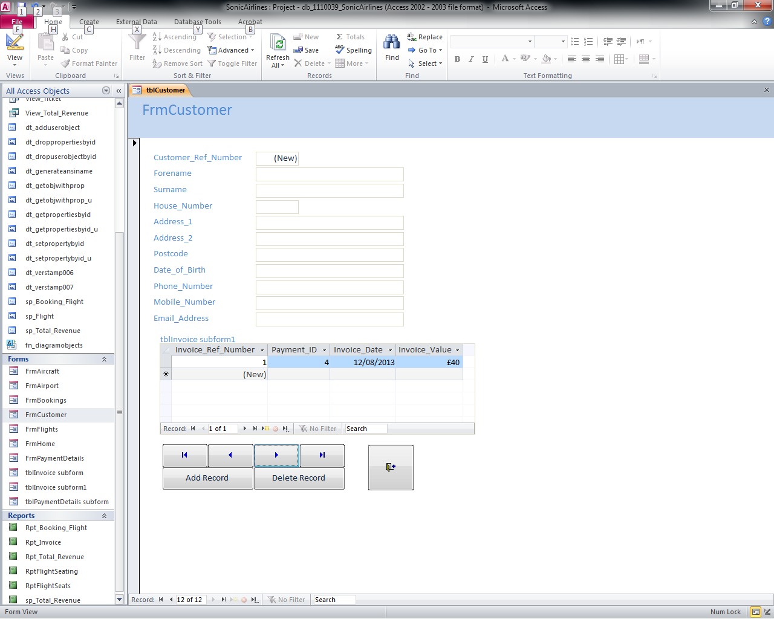

To add a new record to the table click the last record button and the next record button to get to a black record that can be filled in as shown above. Simply fill in the details and click the Add Record button as shown below. The record will now be added to the table

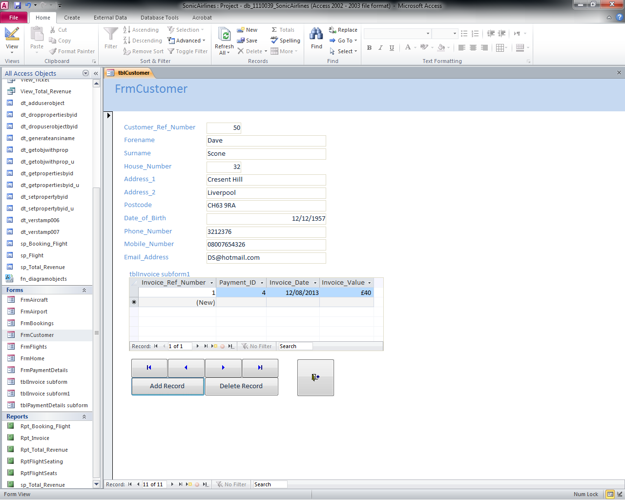

### Delete Record



To delete a record form the table use the button as shown above. When pressed a warning message will appear similar to the image below. If confirmed the record will now be deleted form the table.

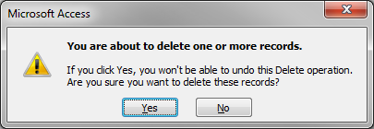

### Close Record



To close a form and return to the homepage click the close form button as shown above. This will take you back to the homepage as shown below.



## Report Buttons

### User Input



When you press one of the report buttons on the home page as shown above it will prompt for user input. An example of the prompt is below.

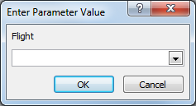

Using the information the user has provided it will create you specific query and display the results as shown below.



### Print Report



To print a report simply click the print button as shown above. When pressed a print message shown appear as shown below and when you choose you options and accept the report will print.

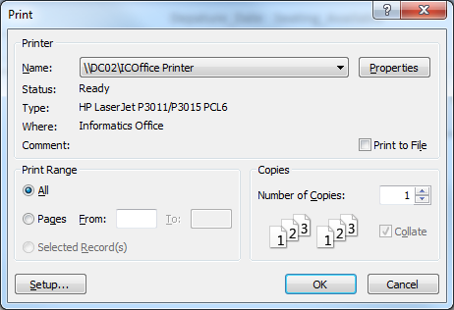

### Close Report



To close the report click the close report button as shown above. This will take you back to the homepage as show below.

